Scordelis–Lo roof penalty study
Objective:
To study the influence of penalty factors on the Scordelis–Lo roof benchmark problem with conforming and non-conforming multi patches
- Study:
The dimensions and model details of the Scordelis–Lo roof are shown in Fig. 1. A single-patch Scordelis–Lo roof is modeled and validated against benchmark results to ensure that BC are correctly modeled (Fig. 2).

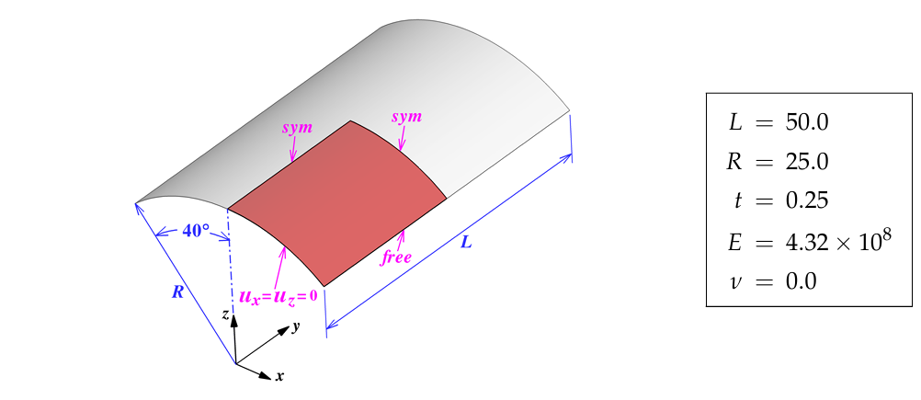
Fig.1 - Scordelis–Lo roof

Then, a Scordelis–Lo roof with multiple patches is modeled, as shown in Fig. 3. This model is designed such that the connecting edges are conforming. The results of this model are compared with the benchmark. Then, the number of control points (or knots) is mismatched between the patches, as shown in Fig. 4. This model is then compared with reference results.
For both conforming and non-conforming models, the Young's modulus is varied to study the range for which the default 1e10 penalty is valid. Since this is a linear model, the results can also be used to determine the range of penalty values for which the results are accurate.
Then, instead of a standard penalty value, the method from the paper by Austin J. Herrema et.al is used. The range of Young's modulus for this penalty value is also studied.

2.1 Single patch:
For a single match, the Maximum displacement obtained is 0.3006. This corresponds to the benchmark results. The degree of polynomial is 3.
Number of CP in X direction = 10
Number of CP in Y direction = 10
Penalty = 1e10
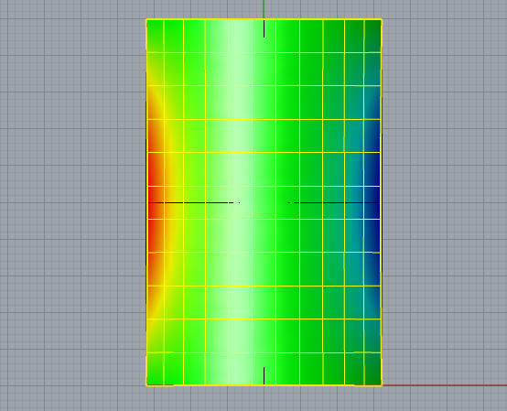
Fig.2 – Single Patch Scordelis–Lo roof

2.2 Conforming multi-patch:
The conforming multiple patch Scordelis–Lo roof model is shown in Fig. 3. The model is divided into 9 patches. The number of control points across all patches and the degree is kept constant and the degree of polynomial is 3
Number of CP in X direction = 2
Number of CP in Y direction = 2

For Study 1, a standard penalty value of 1e10 was maintained, and for Study 2, the penalty value was calculated using material properties as described by Austin J. Herrema et al. According to them,
α_{d} = α Et / [ h (1 − ν²)] – Penalty factor for axial
α_{r} = α Et³ / [ 12h (1 − ν²)] – Penalty factor for rotation

E – Young's Modulus,
T – thickness
ν – Poison ratio
h – length of local element
α – standard penalty = 1000
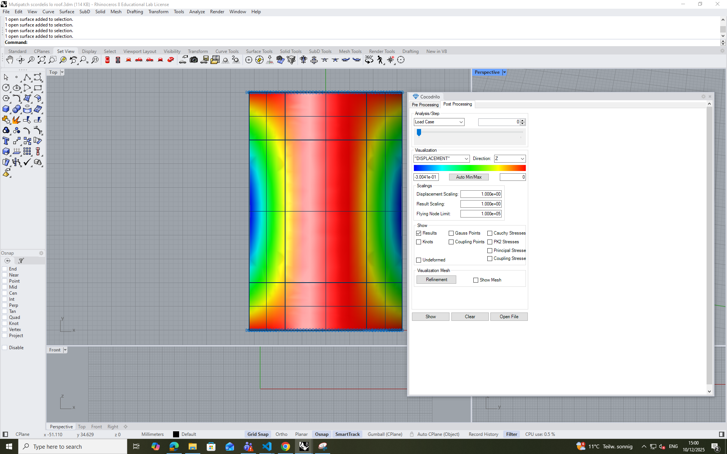

Fig.3 – Conforming Multi-Patch Scordelis–Lo roof
Since, in Kratos (via the project parameters file), only a single value of penalty can be set, α_{d} is used. The h value will also vary across each patch. Hence, the minimum patch element distance of all patches is taken. It is calculated by considering the shortest edge of the patches and dividing it by the number of Gauss points.
H = 0.75

To study the working range the Young's modulus for standard penalty of 1e10 (or influence of penalty factor), Young's modulus is varied from 0.0432 to 4.32e+8, and their corresponding maximum displacement is obtained – Table 1. Also, in each of these young moduli, the penalty factor from Austin J. Herrema et al is also used, and the corresponding displacement is obtained. Since it is a linear model, displacements are scaled accordingly for comparison.
From Fig. 5, we can infer that using Austin J. Herrema allows for a wider range of Young's modulus.

Young’s Modulus | Modified displacement penalty | Scaled displacement with standard penalty | Scaled displacement with modified penalty
4.32E+08 | 1.44E+11 | 0.3047 | 0.3004
4.32E+06 | 1.44E+09 | 0.3047 | 0.3004
4.32E+04 | 1.44E+07 | 0.3047 | 0.3004
4.32E+02 | 1.44E+05 | 0.3047 | 0.3004
4.32E+00 | 1.44E+03 | 0.3054 | 0.3004
0.0432 | 1.44E+01 | 58.873 | 0.3004
4.32E+09 | 1.44E+12 | 0.3006 | 0.3004
4.32E+10 | 1.44E+13 | 0.3068 | 0.3004
4.32E+12 | 1.44E+15 | 0.4136 | 0.3004
4.32E+14 | 1.44E+17 | 6.814 | 0.3004
4.32E+16 | 1.44E+19 | 612.74 | 0.3004
Table 1: Conforming Multi-Patch Scordelis–Lo roof Results

Fig. 5: Conforming Multi-Patch Scordelis–Lo roof Results

2.3 Non-Conforming multi-patch:
For the non-conforming multi-patch, all parameters are kept the same, except for the number of control points and h. The number of CP for each patch is given below and refer to Fig.4.

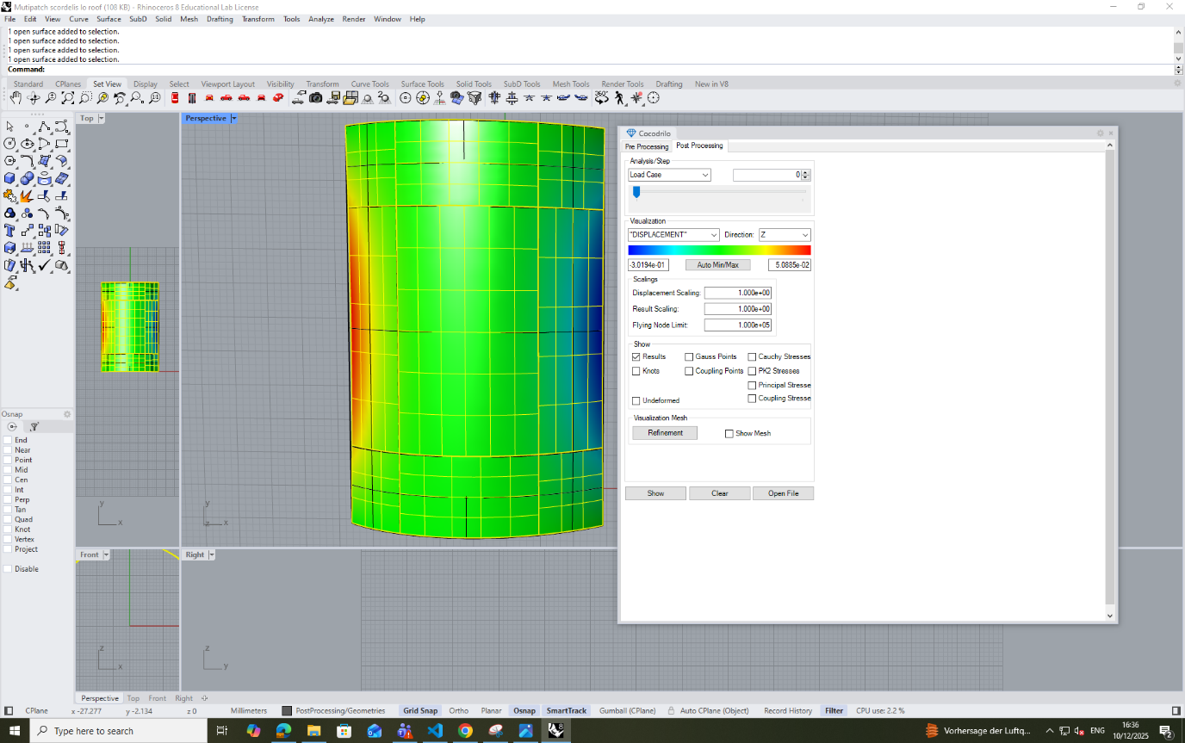
Fig.4 – Non-Conforming Multi-Patch Scordelis–Lo roof

Patch 1  Number of CP in X direction = 2  Number of CP in Y direction = 2 | Patch 2  Number of CP in X direction = 3  Number of CP in Y direction = 4
Patch 3  Number of CP in X direction = 2  Number of CP in Y direction = 2 | Patch 4  Number of CP in X direction = 4  Number of CP in Y direction = 3
Patch 5  Number of CP in X direction = 5  Number of CP in Y direction = 5 | Patch 6  Number of CP in X direction = 4  Number of CP in Y direction = 3
Patch 7  Number of CP in X direction = 2  Number of CP in Y direction = 2 | Patch 5  Number of CP in X direction = 3  Number of CP in Y direction = 4
Patch 9
Number of CP in X direction = 2
Number of CP in Y direction = 2

Since the number of control points changed, the h value should also be recalculated. Hence,
h = 0.625.

Table 2 and Fig.6 show the results.

Young’s Modulus | Modified displacement penalty | Scaled displacement with standard penalty | Scaled displacement with modified penalty
4.32E+08 | 1.73E+11 | 0.3019 | 0.3012
4.32E+02 | 1.73E+05 | 0.299 | 0.3012
4.32E+00 | 1.73E+03 | 0.298 | 0.3012
4.32E-02 | 1.73E+01 | 0.00715 | 0.3012
4.32E+09 | 1.73E+12 | 0.3023 | 0.3012
4.32E+10 | 1.73E+13 | 3.043 | 0.3012
4.32E+12 | 1.73E+15 | 0.00417 | 0.3012

Table 2: Non-Conforming Multi-Patch Scordelis–Lo roof Results

Fig. 6: Non-Conforming Multi-Patch Scordelis–Lo roof Results

Inference:

- Kratos IGA exhibits good results for the standard penalty number for both conforming and non-conforming multi-patches

- By comparing conforming and non-conforming patches, it is observed that conforming patches have a greater range of valid Young's moduli (or alternatively, penalty factors).

- Using the modified alpha proposed by Austin J. Herrema et al, a greater range of Young's modulus or penalty factors can be achieved.

